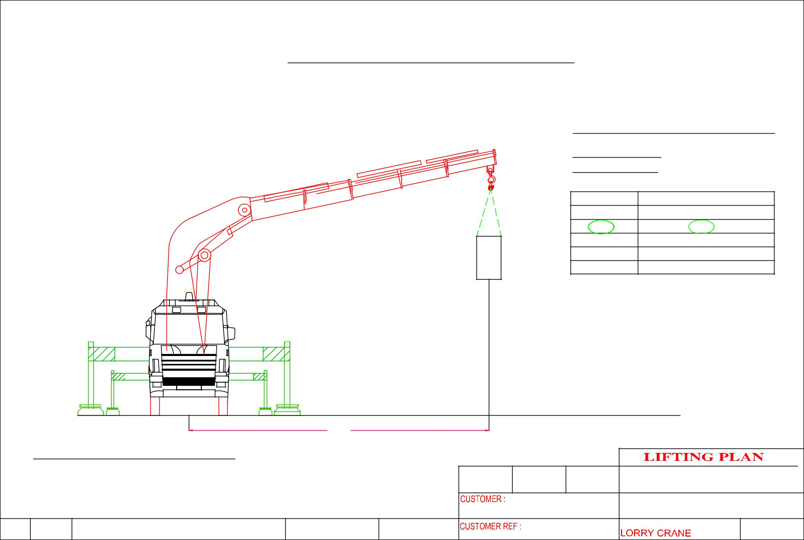
 |  |  | LIFTING PLAN – BlK 5012 A.M.K Ave 5 #01-10 (LHY Engineering (S) PTE LTD)
 |  |  |  |  |  |  |  | CRANE :PALFINGER PK100002E
 |  |  |  |  |  |  |  | LORRY CRANE
 |  |  |  |  |  |  |  | CRANE CONFIGURATI0N
 |  |  |  |  |  |  |  | OPERATING RADIUS : 6m
 |  |  |  |  |  |  |  | ^{OPT . RADIUS(m)} |  | LIFTING CAPACITY OF CRANE IN KG
 |  |  |  |  |  |  |  | 4 |  |  | 16,900
 |  |  |  |  |  |  |  | 6 |  |  | 12,200
 |  |  |  |  |  |  |  | 8 |  |  | 9,100
 |  |  |  |  |  |  |  | 10 |  |  | 7,100
 |  |  |  |  |  |  |  | 12 |  |  | 5,700
 |  |  |  |  | MACHINE WEIGHT | 9,500 KG |  | SAFETY FACTOR CALCULATION
 |  |  |  |  |  |  |  | WEIGHT OF MACHINE |  |  | : 9,500 KG
 |  |  |  |  |  |  |  | LIFTING ACCESSORIES WEIGHT : 50 KG
 |  |  |  |  |  |  |  | TOTAL WEIGHT OF LIFTING |  |  | : 9.550KG
 |  |  |  |  |  |  |  | LIFTING CAPACITY |  |  | : 12,200KG
 |  |  |  |  |  |  |  | SAFETY FACTOR |  |  | :1,277 KG
 |  |  |  | 6M
 | CRANE :PALFINGER PK100002E
 |  |  |  |  |  |  |  |  | ERIC WONG MACHINERY TRANSPORTATION P/L
 |  |  |  |  |  |  | LHY Engineering (S) Pte Ltd |  | DRAWING NAME:
 |  |  |  |  |  |  |  |  | HOISTING OF MACHINE

